# **See how much you've grown**

﻿﻿At the start of this course, you evaluated one of your presentation. This was your presentation baseline. Now, it's time to do this again.

**For the best comparison, do the same presentation again.** Follow these 3 steps:

1. Improve the presentation
2. Deliver the presentation
3. Evaluate your presentation (yourself or ask feedback from the same person who evaluated your baseline presentation)

﻿﻿If you don't want to do the same presentation again, you can use a new presentation as your "after-course" data point.

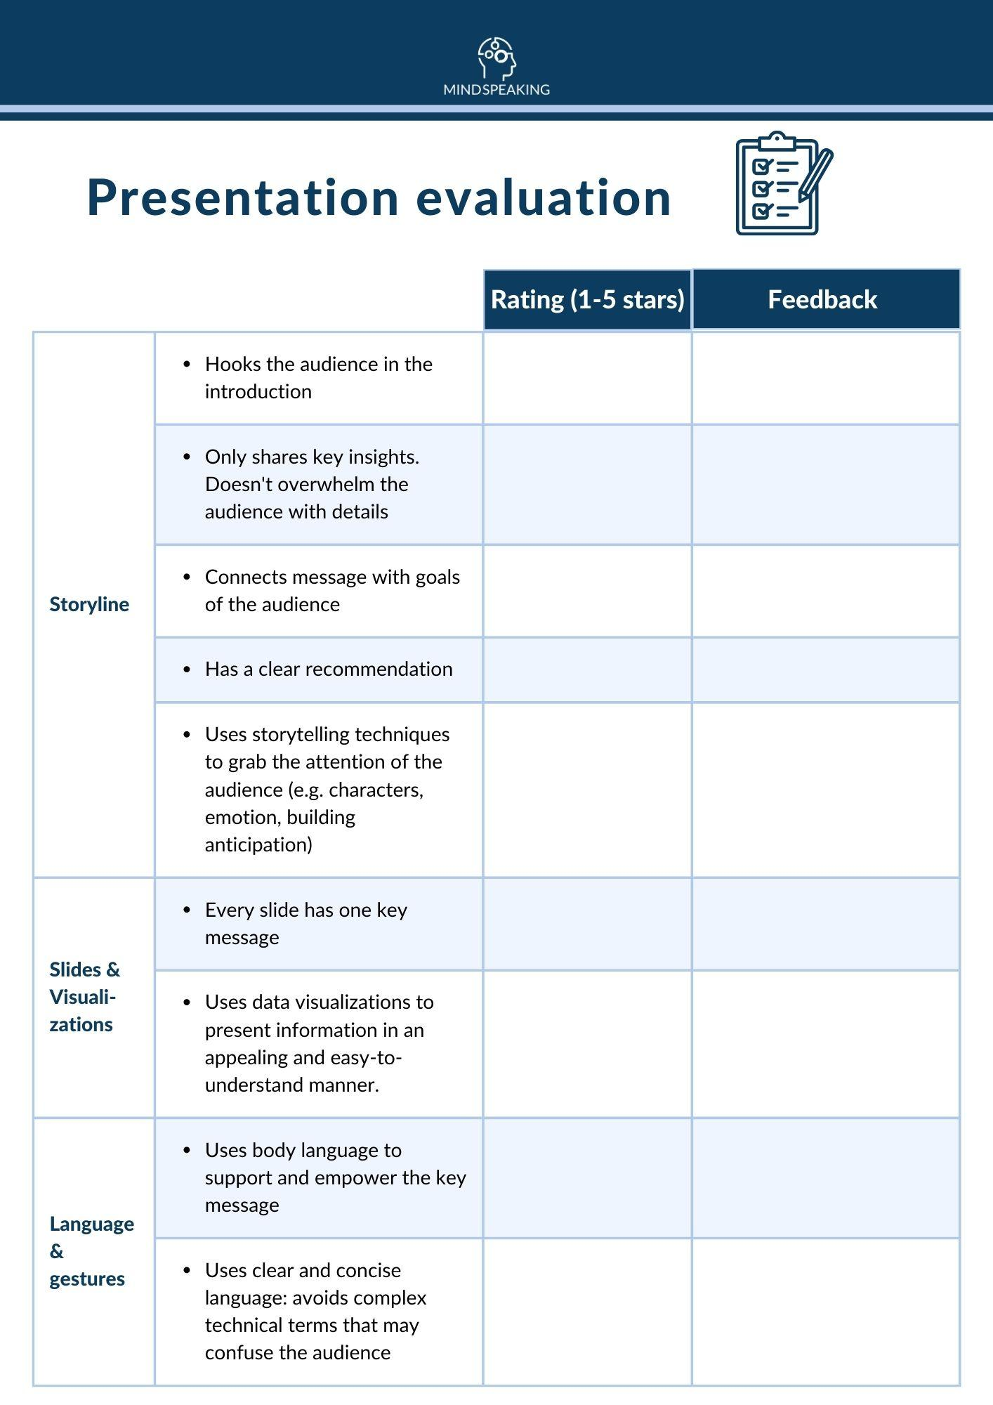  
﻿﻿

﻿﻿

Want to print the evaluation sheet?

Download the PDF below: